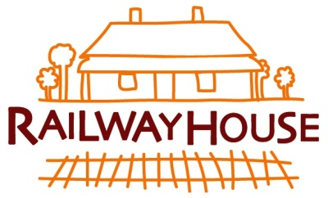

NORTH CARLTON RAILWAY NEIGHBOURHOOD HOUSE

APPLICATION FOR MEMBERSHIP 2019 / 2020

We encourage everyone who participates in our programs to become a member of Railway House.

When you join Railway House as a member, you’re joining a community of people that care about each other and about the things that shape our community. As well, you’ll be able to propose and vote on motions at Annual General Meetings and nominate to be a member of our Committee of Management.

I, (full name) ………………………………………………………………………………

Address:…………………………………………………………..……………………….

Phone number: ………………………………….....................................

Email address: .....................................................................................

wish to apply for Membership of the North Carlton Railway Neighbourhood House.

I understand and support the purpose of North Carlton Railway Neighbourhood House, which is “to strengthen community through its programs and activities”. As a Member, I would comply with its Rules of Association (these can be provided on request).

Signed……………………………………………….. Date………………………..

Membership Fees

Fees are set at $2, $5, or $10 depending on your income. If you would also like to make a donation to support the work of Railway House we would be very grateful. Fees and donations can be made at the office or via bank transfer:

Name: Railway House
BSB: 313 140
Account Number: 12054263

